Design Specification

Chasemaster

Dejan Lazic, 09106642, dejan.lazic@student.ncirl.ie

BSc (Hons) in Computing

Cloud Computing

23/09/2012
starting and targeted position

* Introduction

** Flow

* draw Flow of components accross the layers

** Description

Chasemaster is an online variation of a chess game. What differentiate Chasemaster from a typical chess game is that it is not played by two players opposite each other, but one player tries to win a group of players on the other side of a board. The single player always plays with white ???, and group of players, whose starting number is configurable, play with black ???.
They play alternately, beginning with a white player making a movement, then a group moves at the same time. All individual movements of the group's players are grouped by starting and destination fields, to get sets of identical movements. One of the all performed combinations is chosen as a winning combination and all the players with movements in that group continue playing against a white player. The criteria for determining a winning "from-to" fields group is number of movements per each group, and combination with the largest number of idedntical movements is taken to continue the game. The rest of players from a group get out of game. If there are two or more combinations of "from-to" fields with the same number of performed movements in them, than the group with the shortest total performance time is chosen as a winning group.

SLAST of Chasemaster is on one side in challange for an individual player to beat a group of people, and on the other hand in OCEKIVANJU which movement will PREVLADATI and either to continue game or win an individual player.
Piculiarity of this game is that not always the best movements continue game, but it can even be the worst movement if majority of players performed individually to make such a worse movement.

There are two types of players:

- individual (does not require registration; winner form a current match stays); starts as WHITE

- group (requires registration, registered player automatically put in GROUP); starts as BLACK

Persistance
At the beginning of every match a new match is creatd in database. Then each turn is added for a particular match and all the individual players' movements per turn are saved. This data can be used for some deeper analysis (group players behaviour and similar statistics), the functionality neither planned not implemented in this phase of the project.

Architecture

Apress: Pro Spring 3 (p592) - diagram + desc

* GameConst - contains all the keys from web.xml
* admin un/pwd in web.xml

Chasemaster is architectured in standard N-tier approach, with the following separate layers:

- Web client
- Service
- Data Access
- Persistence

* Web

Since the application is heavily based on JavaScript and Ajax communicaiton with the server side, it is designed with two separate CJELINE, around two servlets:

* ???Servlet - takes control over users management
** Central Controller: MVC pattern (basic functinalities)

** GameServlet: asynchronous servlet that handles Ajax reqests and postponed responses (server push
technology). It triggered controller

* Service

Contains all necessary data access object (DAO) objects, and deletates tasks to one or more these DAO objects.

* Because all clients must wait until the last one sends his movement (to be able to choose winning movement before returning response to clients), I'll have to implement either stateful WS (EJB or Spring?) (preferred) or asynchronous WS + reading response from file/MOM (queue).

- see Journal #5 for details about Asynchronous Ajax details (instead of WS)

Asynchronous Web
Legacy web applications are synchronous in nature. The user interacts with the web interface presented in the browser, the browser makes requests back to the server based on that user interaction, and the server responds to those requests with new presentation for the user - fundamentally a synchronous process. This means that the presentation delivered to the user represents a snapshot in time of what is a dynamic system. That snapshot becomes stale in between user interactions and does not necessarily provide an accurate view onto the current state of the system. Even when you bring Ajax techniques into the equation this synchronous process is unchanged. While the use of XmlHttpRequest and Ajax techniques facilitates a more fine-grained interaction model than a full page refresh, the requests are still generated based on user interaction, so the process remains synchronous, and the potential for a stale view onto the system persists.

In the Asynchronous Web it is possible to deliver spontaneous presentation changes to the user as the state of a dynamic system changes, without the need for the user to interact with the interface.
When you have multiple users interacting with the same system, the interactions of one user can spontaneously impact what other users see, thus creating a truly collaborative system - the essence of what Web 2.0 promises.

To achieve the Asynchronous Web we need to be able to send responses back to the browser spontaneously, but how can this be achieved within the confines of the HTTP protocol? We cannot send a response to a non-existent request, so it is necessary to manipulate the request/response mechanism to achieve the desired effect.

There are three common techniques for implementing a Push protocol on top of HTTP:
polling, long polling, and streaming.

HTTP Polling

The most straight forward way is with a basic polling mechanism. Send requests on a regular basis, and give the system continuous opportunities to update the presentation. This technique, which is illustrated below, is not ideal as there is no ideal polling interval. There is a necessary trade off between timely updates and chattiness of the system. As illustrated, it is possible for multiple events to occur between polls, but it is also possible to have no events occur. In the final analysis, polling is not a truly asynchronous mechanism.
Polling is not a particularly good option because it always seems unresponsive: either you choose your polling interval to be short in an attempt to receive messages with a minimum delay, and you swamp the server with polling requests (which makes the application unresponsive), or you choose your polling interval to be long to reduce load on the server, and the application seems unresponsive because the messages are not delivered in a timely fashion. Fundamentally, polling is not the right choice for building an event-driven system. (To be fair, there are application cases with very long polling intervals that make it the right choice; for instance, updating a page containing a report on today's final weather statistics. These are not collaborative applications, however).

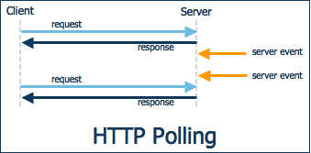

HTTP Long Polling

The request is made in anticipation of a future response, but that response is blocked until some event occurs that triggers its fulfillment. This mechanism, which is illustrated below, is nearly as efficient as streaming and is completely compatible with proxy/firewall configurations as it is indistinguishable from a slow responding server.

Long polling (or "blocking HTTP") makes use of a delayed response on the server to push a message at the desired time. The browser performs an HTTP request for a message, and the server simply delays until a message is available, whereupon the process repeats with the browser again making a request for a message. This effectively inverts the message flow of HTTP. Since a slow server cannot be prohibited by the HTTP specification, this technique works well through proxies and firewalls. The only drawback is the network overhead required by the message requests, but this can be mitigated by accumulating messages on the server and sending them in batches.

So long polling provides a viable mechanism for supporting the Asynchronous Web, and is in fact the mechanism used in industry implementations like Ajax Push and Comet. While the mechanism is relatively simple, the ramifications of holding these blocking requests indefinitely are not. We will now examine these in more detail beginning with the Servlet.

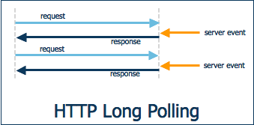

HTTP Streaming

Multiple responses can be sent to a single request, as illustrated below. This is an efficient mechanism, but unfortunately is not ubiquitously acceptable across all proxy/firewall configurations, making it unsuitable for general purpose deployments.
HTTP streaming is the most efficient at the TCP level, but unfortunately encounters some complications with proxies and the JavaScript API. The potential problem with an HTTP proxy is that (depending on configuration) it may choose to buffer the HTTP response until it is complete. In the case of streaming, the response isn't complete until the application has exited, resulting in no messages being delivered to the browser. The other problem is that JavaScript does not provide a read() API, so to read from a stream, it is necessary to collect the entire stream as a buffer in memory, essentially becoming a memory leak in the browser.

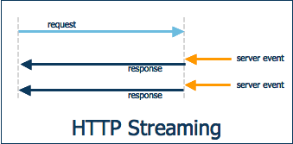

Scalability issues

With Servlet 2.5, holding onto an HTTP response means never emerging from the service() method, thereby consuming a thread. Since we need a push connection for each user, this causes us to consume a thread on the server for every single user. That's not generally good for scalability.

Instead what we need to do is handle multiple requests and responses with a small thread pool.

The Tomcat 6 API is perhaps closest to the NIO underpinnings of asynchronous request processing. The Tomcat CometProcessor interface must be implemented by the servlet handling the push interaction, but once in place, a variety of events are available, and the request and the response can be manipulated by an arbitrary Thread.

import org.apache.catalina.CometProcessor;
02.
03.public class Processor implements CometProcessor {
04.
05.public void event(CometEvent event) {
06. request = event.getHttpServletRequest();
07. response = event.getHttpServletResponse();
08.
09. if (event.getEventType() == EventType.BEGIN) { ...
10. if (event.getEventType() == EventType.READ) { ...
11. if (event.getEventType() == EventType.END) { ...
12. if (event.getEventType() == EventType.ERROR) { ...
13.}

Later, when it's time to update the page with a chat message, event.close() causes the response to be complete and flushed to the browser.

message.setValue("Howdy");
response.getWriter().write(message);
event.close();

The Two-Connection Limit
Having a great server API is only part of the story. A practical problem encountered when trying to implement push is the fact that most browsers generally have a limit of two connections to a given server. If the user opens two browser windows with each window attempting to maintain a push connection with the server, both of the permitted TCP connections are consumed. This means that any user events (such as clicking on a button or a link) will not be sent to the server -- there isn't an available TCP connection to deliver it over. Therefore, we need to share a single TCP connection across the multiple browser windows.

Asynchronous Servlets?
Normal request processing in the Servlet requires a thread per request, so if we are going to block these threads indefinitely, and we need one request per client, thread exhaustion in the application server can occur very quickly. The Java EE specification is poised to address this problem in the Servlet 3.0 specification (JSR 315), with the introduction of asynchronous request processing (ARP) that will be well-suited to the long polling mechanism. In the meanwhile, industry solutions have outpaced the standards process, with a variety of ARP solutions including:
- Tomcat 6 Comet Processor
All of these mechanisms are well-suited to long polling, but they are all different, which means that any solution will have to be customized to the target deployment environment.

What client-side processing is required?
Long polling needs to be driven from the client, making some amount of client-side processing a requirement for supporting the Asynchronous Web. At a minimum, we need a mechanism to manage the blocking requests associated with the long polling, and a mechanism to update the presentation when responses occur, as illustrated below.

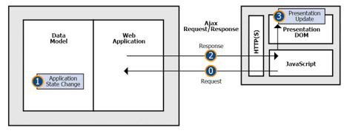

The process goes as follows:
- The initial blocking request is sent using XmlHttpRequest to initiate the long polling sequence.
- Some state change in the application generates a response containing presentation updates.
- The generated response is delivered to the client.
- Client-side JavaScript handles the response and updates the presentation.
- Loop back to the 0 state where another blocking request is generated.

Comet

Comet allows you to send information from the server to the browser without the browser having to ask for it first.

Chat and Collaboration

multiple users share a larger domain model

Figure l-A: Mixing conventional Ajax and Reverse Ajax in a collaborative application

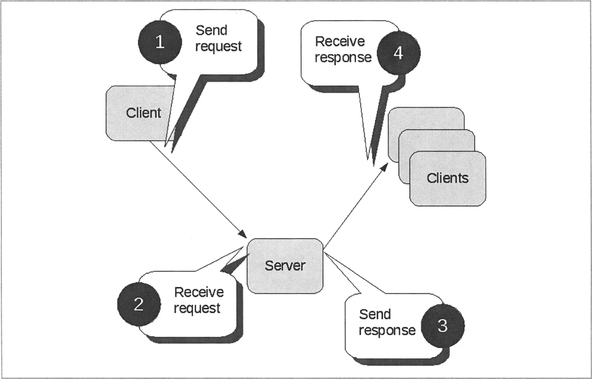

The sequence of events in this situation combines conventional Ajax HTTP
calls with reverse Ajax. When one user submits an update, in a clientinitiated
exchange, the server may decide that other clients need to receive
that update immediately. Reverse Ajax is then used to communicate these
updates.

In collaborative applications, for example, live chat systems and auctions, the entire workflow depends on instantaneous updates, so Comet has a significant role to play.

Implementation

Web Client

Ajax Push
In order to design event-driven system, it is necessary to implement asynchronous push communication between clients and server.
The problem behind is that the server has to collect data from all requests coming from group of players, and only then it can process given data and return response to all of them (delayed response). In this case synchronous communication is inappropriate because all clients would keep open transaction until they get response from the server, what is inefficient in terms of performances and scalability..

Server

Web service

CXF framework
Bottom-up approach - WSDL class is generated by CXF from annotated service object.

DAO
JDBC

Data model

Web user interface

Persistence

DAO

Appropriate DAO implementation is configured in web.xml for ControllerServlet.

MySQL RDBS

DB connection is Configured in web.xml for ControllerServlet.

* DB persistence: JDBC, prepared statements, DAO design pattern

Deployment

Two war files:
- ChessmasterWS.war
- Chessmaster.war

In production can be deployed independently on two or more instances of Tomcat web containers, but for purpose if this project both are deployed on the same instance.

WS is built using

Source control

Git repository
Locations:

Prerequisities

Server side

Java JRE 6

Tomcat 7

? MySQL RDBMS 5

Client side

Internet browser which supports CSS 3: FF v?, IE v?, Chrome v?

cookies enabled

Technology stack

Name | Version | Description
Java | 5 | Programming language
Tomcat | 7 | Web container
JDBC driver |  | Relational database management system
Ant |  | Build manager

Literature

Comet and Reverse Ajax. Apress.

